Chip Maestro Owners Manual

Precautions
- (Power supply Information here)
- Keep away from liquids
- Do not keep in direct sunlight
- It is important to note that a MIDI keyboard capable of reaching the -1 Octave is used. Most new keyboards should not have a problem with this, but some older models may only reach the 0 octave.
- Directions must be read and followed very carefully. If not followed properly, the device will not work as expected.
Quick Start
- Insert the Chip Maestro cartridge into the NES.
- Connect MIDI cable to the cable coming out of the Chip Maestro
- Connect the other end of the MIDI cable to your MIDI Keyboard’s MIDI Out
- Connect the RCA Audio Out of NES to Amplifier/TV/ Speaker System
- Turn on NES and Keyboard
- Play the classic sounds of the NES!

You are now playing the real chip sounds of the NES by using a MIDI keyboard.

IMPORTANT
After you have finished connecting and starting your Chip Maestro, it is very important that you locate the Reset Button. The Reset Button can be located by shifting the octave of your MIDI keyboard to its lowest octave and pressing the A# key. This button is the go-to button if something goes wrong with your Chip Maestro. It is the lowest functioning button on the Chip Maestro and can therefore be used as a good reference point for finding other important keys. When this button is hit, a little jingle will be heard.
* The reset button on the actual NES does not function the same as the reset button on the actual Chip Maestro.

1. Selecting Sounds
The Chip Maestro has four different sounds to play; Triangle Wave, Square Wave 1, Square Wave 2, and Noise. While selecting what sounds to use, one must also set the order in which the sounds will be played.

- Press the Octave Shift Down button until the keyboard is at it’s lowest functioning octave
- Press the D key directly right of the Reset Button, to enter Program Mode. *Note that no noise will sound when the key is pressed
- Select the desired sound or sounds in the order that you would like them to play in, by using the keys E, F, G, and A; all directly right of the Reset Button. (E – Triangle, F - Square 1, G - Square 2, A - Noise.)
- Press the D key again to exit Program Mode. *Note that no noise will sound
- Press the Octave Range Up button and begin playing the classic NES sounds!

As an example, if one wanted to play only Square Wave 1 and Square Wave 2, the following procedure would take place. Press the Octave Shift Down button until the keyboard is at its lowest octave. Press the D key, followed by the F key, then G key. Finally, press the D key again. Now Square Wave 1 and Square Wave 2 will be heard when playing the keyboard. (Remember to use the buttons directly right of the Reset Button.)

2. Changing Modes
The Chip Maestro has three different modes in which it can play:
Poly Mode, Arpeggio Mode, and Slide Mode. To toggle between the three different modes:
- Press the Octave Shift Down button until the keyboard is at it’s lowest functioning octave
- Press the C0 key to toggle between the three different modes.

Poly Mode
Poly Mode is what can be played when the NES is first turned on. The default is set to Poly Mode. In Poly Mode, one can play all the sounds of the NES at the same time.
Refer to Section 3.1 for more details.

Arpeggio Mode
Arpeggio Mode will play every note that is being pressed in a repetitive pattern.
Refer to Section 3.2 for more details.

Glide Mode
Glide Mode allows a player to slide between two notes.
Refer to Section 3.3 for more details.

3. Modifying Sounds
Three of the sounds waves in the NES can be modified. The Triangle Wave is the only sound that cannot be modified.

Modifying Pitch using the Pitch Wheel
The pitch wheel can be used to bend the pitch of one or all notes being played.
Refer to Section 4.1 for more details.

Modifying the Release using the Modulation Wheel
Release is how long a note lasts after a key is no longer pressed. The Release can be adjusted in accordance to how the Modulation Wheel is set.
Refer to Section 4.2 for more details.

Modifying the Noise Wave
The Noise Wave has two main settings: Tinny and Crunchy.
- Press the Octave Shift Down button until the keyboard is at it’s lowest functioning octave
- Press G0 to toggle between the two settings

Modifying the Pulse Width Length of the Square Waves
Modifying the Pulse Width Length of the Square Waves changes the sound of the waves.
- Press the Octave Shift Down button until the keyboard is at it’s lowest functioning octave
- Press C#0 to toggle through the four different Pulse Width settings for Square Wave 1
- Press D#0 to toggle through the four different Pulse Width settings for Square Wave
Refer to Section 4.4 for more information.

Congratulations!
You now are able to use the basic functions of the Chip Maestro. For more advanced users, please continue reading.

Section 1. MIDI Channels
The Chip Maestro can be controlled by computer software (such as Ableton or Fruity Loops) and/or any software that can implement MIDI. MIDI Channels 2-5 are used to access the single dedicated channels for each wave. Each channel’s wave is determined by the previously selected order of Wave Cueing. (Refer to Section 2.1) Meaning that the default mode for the MIDI Channels is as follows;

- MIDI Channel 2 is the dedicated Triangle wave channel
- MIDI Channel 3 is the dedicated Square wave 1 channel
- MIDI Channel 4 is the dedicated Square wave 2 channel
- MIDI Channel 5 is the dedicated Noise wave channel

Keep in mind that this is only the default setting. If the user changes the sound order in Wave Queing , then the channels will directly correspond to the order of waves chosen.

For example:
The user decides to change the default Wave Cueing order of [Tri>Sq1>Sq2] to [Sq2>Tri>Noise>Sq1]. This means that the MIDI Channels were at first:

- MIDI Channel 2 is the dedicated Triangle wave channel
- MIDI Channel 3 is the dedicated Square wave 1 channel
- MIDI Channel 4 is the dedicated Square wave 2 channel
- MIDI Channel 5 is the dedicated Noise wave channel

but are now:
- MIDI Channel 2 is the dedicated Square wave 2 channel
- MIDI Channel 3 is the dedicated Triangle channel
- MIDI Channel 4 is the dedicated Noise channel
- MIDI Channel 5 is the dedicated Square wave 1 wave channel

MIDI Channels 1 and 6-16 will be interpreted as if the Chip Maestro were being played live.

Section 2. Selecting Sounds
Section 2.1
The Chip Maestro has four different sounds to play; Triangle Wave, Square Wave 1, Square Wave 2, and Noise. (Note that the term Square Wave is interchangeable with Pulse Wave) While selecting what sounds to use, one must also set the order in which the sounds will be played. The process of choosing the order in which waves will be played is called Wave Cueing. This feature allows the Chip Maestro to exhibit polyphony using only one instrument.

- Press the Octave Shift Down button until the keyboard is at it’s lowest functioning octave
- Press the D key directly right of the Reset Button, to enter Program Mode. *Note that no noise will sound
- Select the desired sound or sounds in the order that you would like them to play in by using the keys E, F,G, and A all directly right of the Reset Button. (E – Triangle, F - Square 1, G - Square 2, A - Noise.)
- Press the D button again to exit Program Mode. *Note that no noise will sound
- Press the Octave Range Up button and begin playing the classic NES sounds!

As an example, if one would like to play Square Wave 1 and Square Wave 2, the following procedure would take place. Press the Octave Shift Down button until the keyboard is at it’s lowest functioning octave. Press the D key, followed by the F key, then G key. Finally, press the D key again. Now Square Wave 1 and Square Wave 2 will be heard when playing the keyboard.

Section 2.2
Program Parameter Noises
The Program Parameter Noises are the noises that are triggered when the user changes one of the set parameters on the Chip Maestro. For example, when the Noise Wave is toggled between its Tinny and Crunchy settings, a tinny or crunchy sound is heard when the G0 key is pressed. Another example of this could be heard when the Pitch Bend Range is set, as four different bend ranges sound when the F#0 key is pressed.
It is possible to disable these program parameter sounds by pressing the B-1 key, so no noises are triggered when a parameter is changed. This could be useful if a user wants to change parameters in a live setting, but does not want any sounds that are not part of a song to be heard.

Section 3. Changing Modes

Section 3.1
Poly Mode
Poly Mode is what can be played when the NES is first turned on. The default is set to Poly Mode. In Poly Mode, one can play all the sounds of the NES at the same time. Even though each separate wave on the NES is monophonic and can therefore only play one note at a time, all the waves are able to be played together, creating a quadraphonic polyphony. (4 notes simultaneously)

Section 3.2
Arpeggio Mode
In Arpeggio Mode, the user can play one wave in an Arpeggio pattern. Even though only one wave can be played at a time, any combination of notes can be held and all will be cycled through in the arpeggiation.

In Arpeggio Mode, the user has the option to change three separate functions: Arpeggio Speed, Arpeggio Direction, and Arpeggio Sound Selection.

- Arpeggio Speed is controlled by the Modulation Wheel. Mod Wheel Up makes the arpeggiation slow. Mod Wheel Down makes the arpeggiation fast.
- Arpeggio Direction can be set to one of three; Up, Down, or Up/Down (Back/Forth). To change this, press the F0 key. The default is set to Up.
- Arpeggio Sound Selection allows one to choose which of the four different waves that will be played in Arpeggio Mode. To select a wave to play, press the E0 key until the desired wave is heard. *The user must take note that the only waves that have previously been selected in Sound Selection/Wave Cueing will be able to be selected in Arpeggio Sound Selection.

Section 3.3
Glide Mode
In Glide Mode, a note can glide from one note to another. The user must play at least two notes at a time in order for the change to be heard. The Modulation Wheel controls the speed at which the notes glide. Mod Wheel Up sets the glide to the slowest speed. Mod Wheel Down sets the glide to the highest speed.
* The term Glide is also interchangeable with the terms Slide and Sweep.

Section 4. Modifying Sounds

Section 4.1
Modifying the Pitch using the Pitch Wheel
The pitch wheel can be used to bend the pitch of one or all notes being played. It is possible to modify the pitch in all Keyboard Modes. One cannot solo a note within a pitch bend. If the pitch is modified while a chord is held out, all the notes will be affected. Four different Pitch Bend Ranges can be selected by pressing the F#0 key (directly right of the reset button). The default is set to +6 notes, but can be changed accordingly. [+6, +12, +1, +2]

Section 4.2
Modifying the Release using the Modulation Wheel
Release is how long a note lasts after a key is no longer pressed. The Release can be adjusted in accordance to how the Modulation Wheel is set. Release can only be used in Poly Mode. Mod Wheel Up sets the release to the longest release setting. Mod Wheel Down sets the release to the shortest release setting.

Section 4.3
Modifying the Noise Wave
The Noise Wave has two main settings: Tinny and Crunchy.
- Press the Octave Shift Down button until the keyboard is at it’s lowest functioning octave
- Press G0 to toggle between the two settings

Section 4.4 Modifying the Pulse Width Length of the Square Waves
Modifying the Pulse Width Length of the Square Waves changes the sound of the waves. The two Square Waves have four separate Pulse Width settings. The Pulse Width default is set to 50% for both Square Waves, and both can be changed to 75%, 12.5%, and 25%, respectively. See Diagram 1
- Press the Octave Shift Down button until the keyboard is at it’s lowest functioning octave
- Press C#0 to toggle through the four different Pulse Width settings for Square Wave 1
- Press D#0 to toggle through the four different Pulse Width settings for Square Wave

Diagram 1

Pulse Width 50%
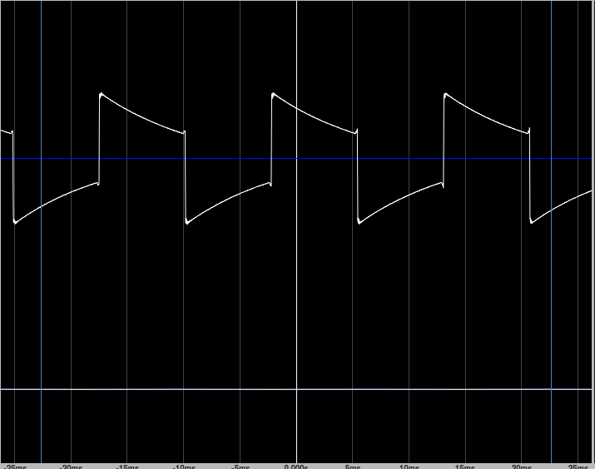

Pulse Width 75%
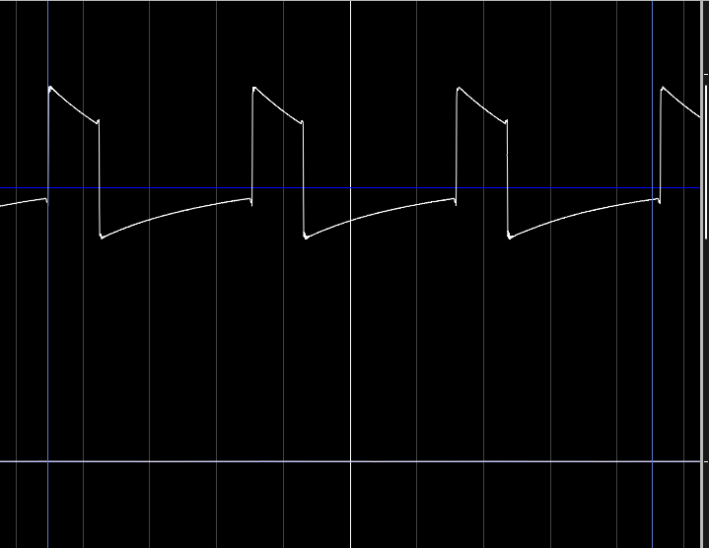

Pulse Width 12.5%
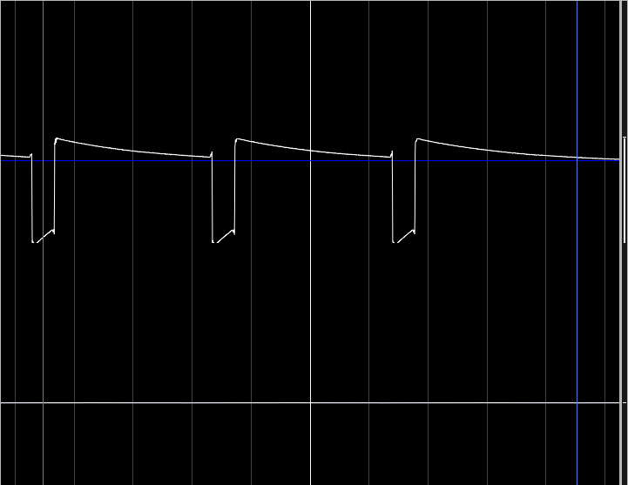

Pulse Width 25%
